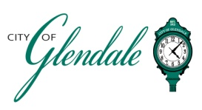
NOTICE OF PUBLIC MEETING
NOVEMBER 17, 2025 – 6 P.M.
BOARD OF ALDERMEN WORKSHOP

- MEETING CALLED TO ORDER
- ROLL CALL
- REVIEW UPDATED DRAFT OF BLUEPRINT GLENDALE COMPREHENSIVE PLAN
- ADJOURNMENT

_______________________
Gabrielle Wesche
Community Engagement Officer Posted 11:30 a.m., November 13, 2025

